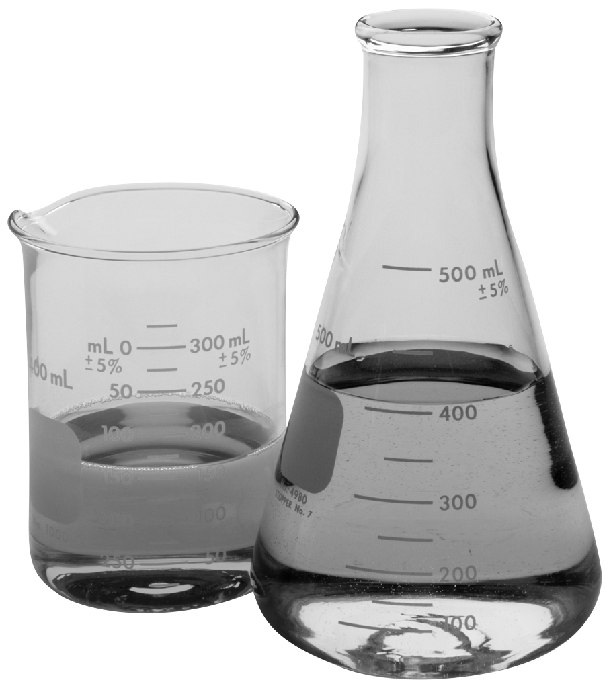 **Mr. Alexander’s Science Class**

**Dear Student,**

Welcome to eighth grade science! I look forward to our year of scientific collaboration and learning. Developing scientific skills will give you college and career choices. I hope many of you will choose to pursue a college-based career in science. We need bright, inquisitive people working in science fields to improve the world and solve future challenges.

**Dear Parents and Guardians**,

Thank you for the opportunity to work with your cherished children. Through open communication and working together we will help your student have a successful year! Please let me know if there is any information you feel I should know that will help your child have a successful year in science.

**Units of Study:**

|  |  |
| --- | --- |
| 1. Engineering | |
| 1. Force and Motion | 1. Energy |
| 1. Waves | 1. Heredity |
| 1. Biological Evolution | 1. Earth’s Place in the Universe |

**Supplies**: In addition to a 2” Binder with a section divider for science, students need their Chromebook, Spiral Notebook for notes, binder paper, pencils/pens, and a highlighter.

*If a student is caught destroying or defacing any of the class supplies or materials, you will be responsible for replacing the item.

**Science Class includes Labs. There will be NO FOOD or DRINK allowed in the classroom at any time (water is okay). Students must use lab and safety equipment properly as directed by the teacher or they will lose lab privileges.**

**Grading:**

|  |  |  |
| --- | --- | --- |
| **Evaluation Criteria** | **Method of Evaluation** | **Grading** |
| Assessments | Quizzes, common assessments, written/oral presentations, projects, and laboratory reports. | 45% |
| Student work | Classwork, class activities and homework | 40% |
| Participation/Responsibility | Class participation/discussions | 15% |

**Grading Scale:**

A = 90-100 %

B = 80-89 %

C = 70-79 %

D = 60-69 %

F = Below 59 %

**Late Work:**

Late Work will not be accepted. If your student is absent, they have the same number of days they were out to make up the work. If there is a special case, your student can come talk to me about the situation. Any missing work at the quarter grade will be given an “I” grade for incomplete. They will have the opportunity to make up any work if they come after school to do it.

**Classroom Management Policy**:

|  |  |
| --- | --- |
| STUDENT CONDUCT EXPECTATIONS: | CONSEQUENCES FOR MISCONDUCT |
| * Student in seat and working on daily warm up activity by the time the bell rings | 1. Verbal Warning |
| * Respect is shown for teacher, self, and classmates | 1. Parent Contact |
| * Materials are brought to class daily | 1. Referral to counselor and/or assistant principal |
| * Student behaves in a way that helps self and others learn | 1. Suspension from class and/or school |
| * 10-10 Rule is followed-No student is allowed outside of class for the first or last 10 minutes of class |



**Student Signature___________________ Parent/Guardian Signature _________________**